iPhone App User Guide

**Christmas Lights Animation**

By: Austin Wentz and Jordan Doell

Interactive Lighting

4/20/2013

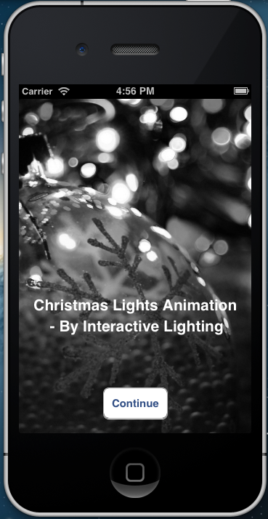

# Table of Contents

Table of Contents

Table of Contents 1

Purpose 2

Storyboard 2

View 1: 3

View 2: 3

Channels: 3

Songs: 3

View 3: 4

View 4: 4

Installation: 5

Maintenance: 5

# Purpose

This iPhone application was developed for the Christmas Lights Animation Project. This app will allow the user to control the system by sending various commands to the server that controls the lights. This user guide will go through each view and give the user details on how to use that view.

# Storyboard

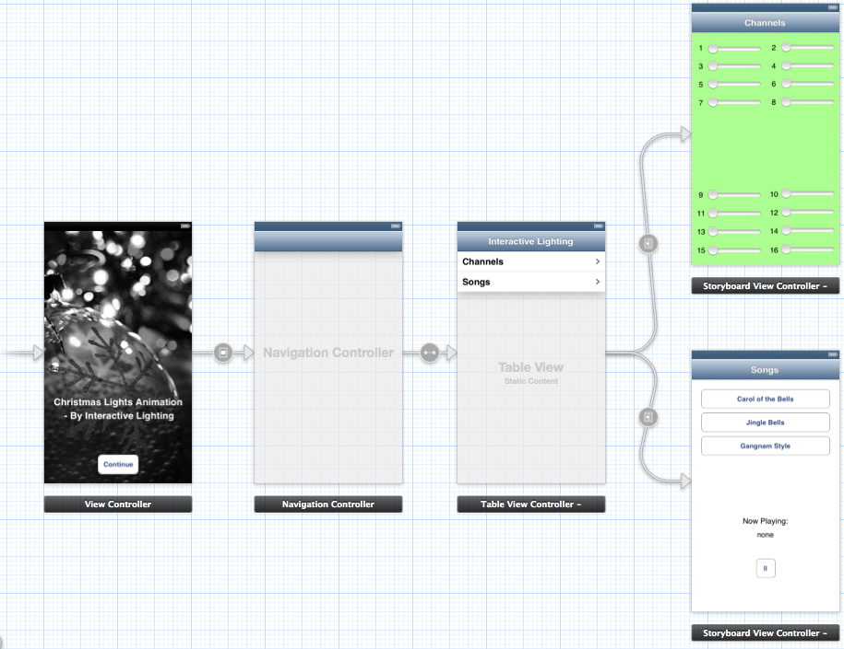

View 3

View 1 View 2

View 4

# View 1:

This is the initial view that you see when the app first opens. By tapping on the continue button, it takes you to the main view for the app, View 2.

# View 2:

The second view of the app shows a table view with two different selections to choose from.

1. Channels
2. Songs

## Channels:

The channels option takes you to view number 3, which allows the user to change the brightness of each individual channel of lights in the system.

## Songs:

The songs option takes you to view number 4. This allows the user to choose a song to play. Also, there is an option to pause the current song that is playing.

# View 3:

This view shows 16 different sliders. Each slider represents a channel, or string of lights. By changing the slider’s value, this changes the brightness for that channel of lights.

# View 4:

This shows the songs that are available to be played with our system. Just tap on the proper button and that song will begin playing. Also, by pressing the pause button, the current song that is playing will be paused.

# Installation:

This application is not yet on the Apple App Store. If it becomes available, it is a fairly simple process to install the app. Search the app store for the Christmas Lights Animation app. Tap on free, then install it after providing your Apple ID and password. Once installed, tap on our icon and the app should start right up.

# Maintenance:

The app should not need much maintenance. However, should the user need to add more songs to the system, there are a few simple steps for adding songs to the app. However, since this is not part of using the app, the information involved with adding songs will be provided in the Software Design Document.